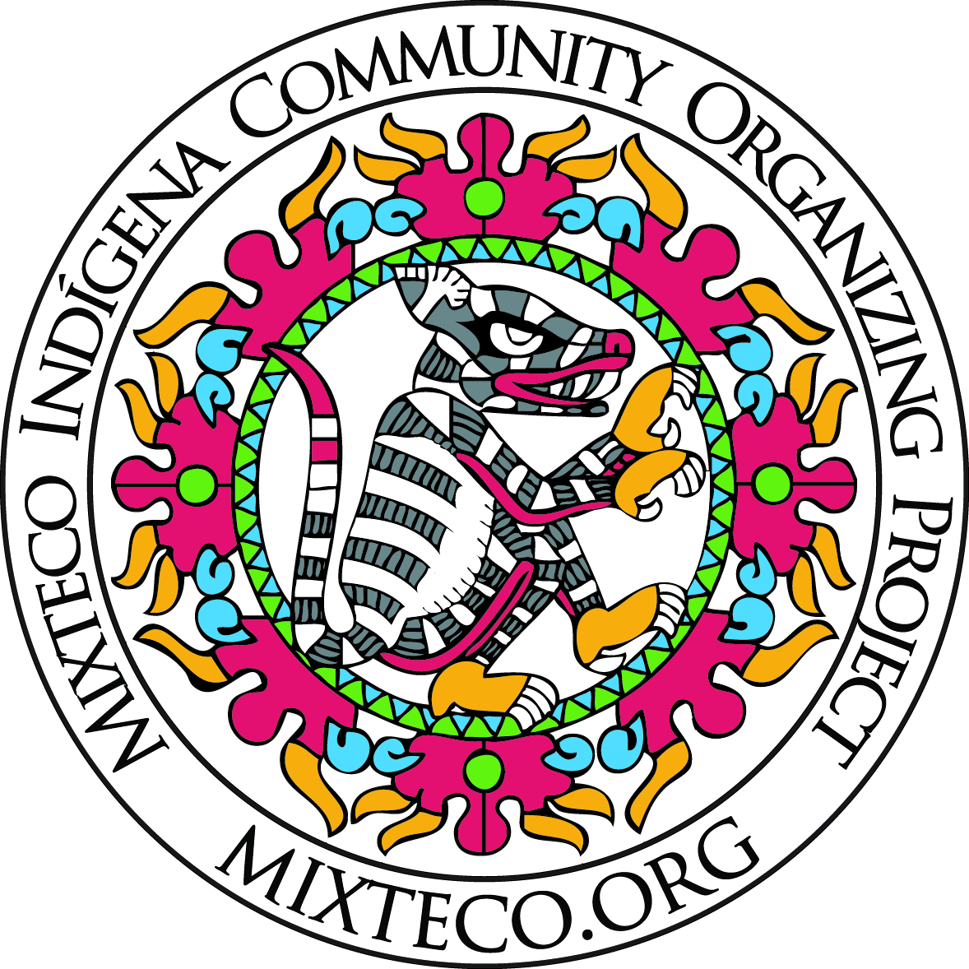
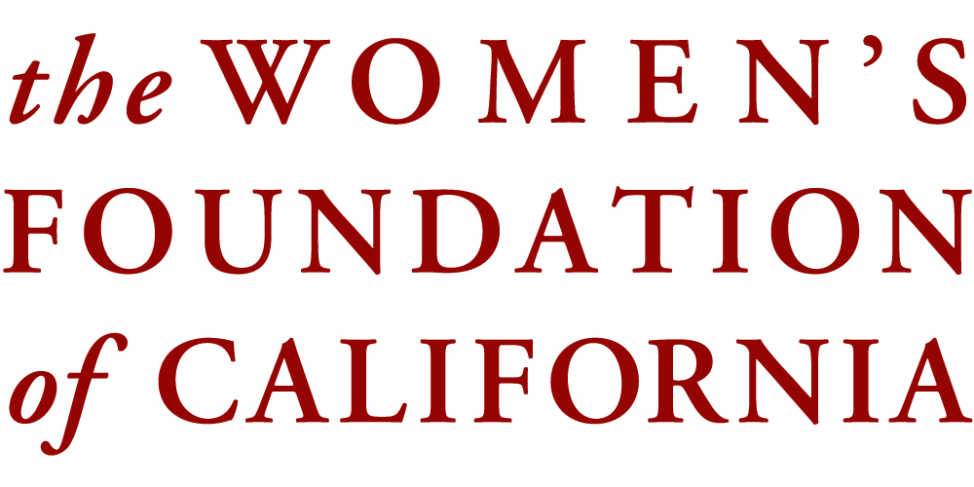

The Women’s Foundation of California and MICOP present:
Indigenous Women Advancing Together
Program Coordinator: Vanessa Terán email: vanessa.teran@mixteco.org Office: (805) 483-1166
MICOP is honored to continue Mujeres Indigenas Avanzando Juntas (MUA-J), a women’s economic mobility initiative of the Women’s Foundation of California. MUA-J is a program advance an indigenous women’s healthcare workforce, to train native speakers of indigenous languages to be health promotors and interpreters through intensive studies and participation in a 1-year supportive Training Cohort. Trainees are required to complete all of the below qualification, personal and professional development activities:
PHASE 1:
- A 40-hour California Healthcare Interpreter Association training
- MICOP’s 8-hour Promotor training
- Must have basic English language skills and competency.
- Participate in monthly professional workshops in MICOP’s Indigenous Interpreter’s Network (once-a-month) with the objectives of professionalism and recognition of indigenous interpreters, exploring options for national certification, skills development, and promoting a sense of unity.
- Participate in Financial Literacy classes
MICOP will provide the following:
- One-on-one case management support and mentorship
- Screenings by MICOP’s enrollment specialist for CalFresh and Medi-Cal
- Workshops to develop resumes within the Indigenous Interpreter Network
- Host site visits of interpreter workplaces for job shadowing
PHASE 2:
In order for you to be considered in Phase # 2 you will have to pass an exam of equivalency and qualification exam.
- From this 5 chosen candidates of the entire cohort will be offered a Certification Study Group for 20 study sessions
- These chosen candidates will receive $500 towards their certification test for CMI or CPHI.
Check will be written out to the national certification agency on behalf of the candidate.

About MICOP’s Training Program:

MICOP strives to train underserved indigenous individuals, in an effort to promote fundamental access to medical, educational, social and legal services. Often low-income and uninsured individuals have limited language access to quality medical and the mental health community. To help support our vision, our Indigenous Language Services provides professional Mixtec interpreters to help local agencies better communicate with their Mixteco and Zapoteco speaking clientele. There are approximately 20,000 Mixtecs in Ventura County, and many are fluent only in their indigenous language. Our trained interpreters ensure client and provider clearly understand each other, overcoming barriers both linguistically and cultural.

- CHIA’s training will be imparted by Maestra Lourdes Cerna and Interpreter colleagues -
CHIA's mission is to increase access to health equality:
Developing and promoting the profession of medical interpreters;
Providing culturally and linguistic appropriate services; &
Providing education and training to health professionals.
California Healthcare Interpreter Association

The teachings imparted within the curriculum include as part of the Ethics of Healthcare Interpreters:
-Ethical principles, protocols and guidance on roles and intervention
- Medical terminology and vocabulary
- Confidentiality, impartiality, understanding and cultural awareness, cultural brokerage, integrity, and respect, etc.
-Simultaneous and Consecutive Interpretation
- Obtaining qualification, registration and certification
Trainings Dates
Please mark your calendars and note that it is necessary and important to complete all SESSIONS
Table 1: CHIA every Satruday from October 22-November 19, 20016 from 9am-5:30pm.
- First Class | 22nd of October
- Second Class | 29th of October
- Third Class | 5th of November
- Fourth Class | 12th of November
- Fifth Class | 19th of November
Promotora Training:
This training specializes in coaching people to create the communication bridge in our communities. They specialize in community outreach, they develop and involved themselves in being a voice that unites and reaches the community. Promotoras build trust in the community, they share similar languages and the same social environment. Promotoras create and participate in being social service providers, agents of social change, educators, and system navigators.
Table 2: Health Promoter
Training (s) to be annouced

Indigenous Interpreter Network:

Tentatively to be held once a month from 6-8pm.
Dates for 2016:
Table 3: Red Lingüística de Intérpretes Indígenas
First Class: | 1st of November (Tuesday)
Second Class: | 5th of December (Monday)

Coaching and Mentorship for Certification of Study Group:

To be held every other Tuesday with the team of 5, taught by Coach Lourdes Cerna via skype.
Dates for 2016 programmed are the following Tuesday (s) from 6-8pm:

Table 4: Certification Coaching Study Sessions
First Class: | 8th of November
Second Class: | 15th of November
Third Class: | 29th of November
Fourth Class: | 6th of December
Fifth Class: | 13th of December
More dates: | To be determined at the end of 2016

Proyecto Mixteco/Indígena
Organización comunitaria

Application for MICOP program:
Mujeres Indigenas Avanzando Juntas
Indigenous'Women Advancing Together

40 horas – California Healthcare Interpreter Association (CHIA), Connecting Cultures Qualification Certificate
8 hours– Promotoras Training

First name:_________________________________________________________________________

Last name:_________________________________________________________________________

Date of Birth: ___________Day:___________Month: _____________Year: _____________________________
Address: ____________
City:______________ State:_________________Zip Code:________________

Cell Phone:__________________________ Email:_________________________________
Receives Text: Yes No Receives Photos: Yes No

RACE/ETHNICITY, please check one:
Unknown
African American/Black
Asian/PAI
Hispanic/Latino
Multi-ethnic
American Indian/NA
White
Mixteco
Zapoteco
Otomi
Purepecha
If “other,” please explain:

Number of DEPENDENT CHILDREN:
Total number of dependent children

EMPLOYMENT STATUS at the time of program enrollment:
Employed full-time (34+ hrs/wk @ one employer
Employed part-time (< 34 hrs/wk)
Unemployed/No earned income
Average wage at the time of program enrollment

Annual HOUSEHOLD INCOME at the start of the program:
 | Start of Application | 6 months | 12 months | 18 months | notes | comments
Less than $15,000
$15,000−$34,999
$35,000−$39,999
$40,000 or above

Availability:
 | Monday  Lunes | Tuesday  Martes | Wednesday Miércoles | Thursday  Jueves | Friday  Viernes | Sabado  Saturday | Sunday  Domingo
From:
To:

Community of Origin

Country:______________________________________________________________________________
State:______________________________________________________________________________
District:____________________________________________________________________________
Municipio/ County:___________________________________________________________________
Agencia/pueblo/ town:______________________________________________________________________

Languages with Fluency (mark those that apply)

Spanish Verbal Written No fluency
English Verbal Written No fluency
Other:__________________ Verbal Written No fluency

Other variants or languages of communities of which I understand, comprehend and can communicate with: __________________________________________________________________________________________
__________________________________________________________________________________________

History of de Education (in Mexico or USA )

Last year of Education: School:

Computer Literacy: Excel? Yes No Word? Yes No Transportation: Yes No

Do you have health insurance? yes no Would you like to get screened for Medi-Cal yes no
Do you need support with Cal Fresh (Food Stamps) yes no

History of Employment

Place: Position: Dates:

Place: Position: Dates:

References:

Name: Relationship.: Telephone:
Name: Relationship.: Telephone:

Questionnaire to the Applicant:

- Describe your experience, understanding or connection to the indigenous immigrant community.

__________________________________________________________________________________________

- What are some of the issues of needs our community confronts?

__________________________________________________________________________________________

- Why are you interested in being a part of the program Indigenous Women Advancing Together?

_______

- What are your current skills, abilities and capacity to contribute to the cohort, classes and workshops?

_______

- What do you hope to learn and what are your personal expectations?

________

_______

- Please, list 3 personal goals and objectives you would like to achieve in this program?

________

_______

- What topics related to healthcare interpreting would you like to see in the future Indigenous Language Interpreter Network meetings? Are there specific speakers or themes you would like us to consider?

________

_______

- What is one thing you hope to accomplish, change or do as a result of being involved in this cohort?

________

_______

- Are there any other comments you would like to share?

________

_______

Please return this application before the end of the day on Monday, October 17th, 2016 or send to:

Attn: Mixteco/ Indigena Community Organizing Project
Mujeres Indigenas Avanzando Juntas 2016-2017
520 W. 5th Street, Suite K, Oxnard, CA 93030
Or scan and email to:
vanessa.teran@mixteco.org

If you have any questions, please do not hesitate to contact:
Vanessa Terán directly at either 805-483-1166 or 805-612-7568.

